**Medical Inventory Management**

**College Name**: SRI KRISHNA ADITHYA COLLEGE OF ARTS AND SCIENCE KOVAIPUTHUR, COIMBATORE.

**College Code:**

**Team ID: NM2025TMID22464**

**Team Members:**

**Team Leader Name:** MOHAMMED SHEBIN S

**Email :**23bsca142mohammedshebins@skacs.ac.in

**Team Member 1 : AJAY RAJ K**

**Email :**23bsca104ajayrajk@skacas.ac.in

**Team Member 2 : DILAN GIBI**

**Email :**23bsca122dilangibi@skacas.ac.in

**Team Member 3 : SHRAVAN A S**

**Email :**23bsca155shravanas@skacas.ac.in

**1.INTRODUCTION**

1.1.Project Overview

This project is a comprehensive Salesforce application to streamline and manage various operational aspects of medical inventory. The system aims to efficiently maintain supplier details, manage purchase orders, track product details and transactions, and monitor the expiry dates of products. Maintain detailed records of suppliers, including contact information. Catalog product information, including descriptions, stock levels. Monitor and track product expiry dates to avoid using expired items. Comprehensive reports to track supplier performance, and purchase orders.

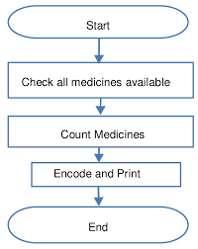

1.2 Purpose

Medical management is a comprehensive process aimed at optimizing patient care and healthcare delivery through a structured and coordinated approach. Its fundamental purpose is to ensure that patients receive the most appropriate, effective, and efficient medical services to improve their health outcomes. This involves a collaborative effort between healthcare providers, administrators, and patients themselves, encompassing both the clinical treatment.

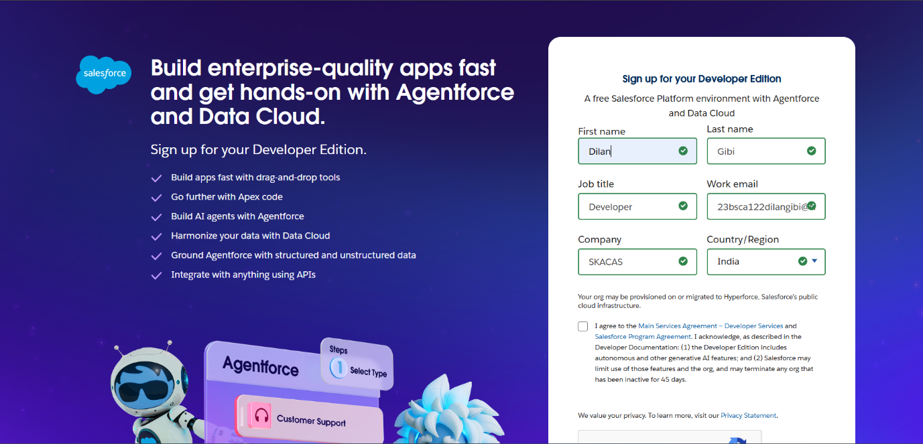**DEVELOPMENT PHASE**

**Created objects: Product,Purchase Order, Order Item, Inventory Transaction and Supplier objects**

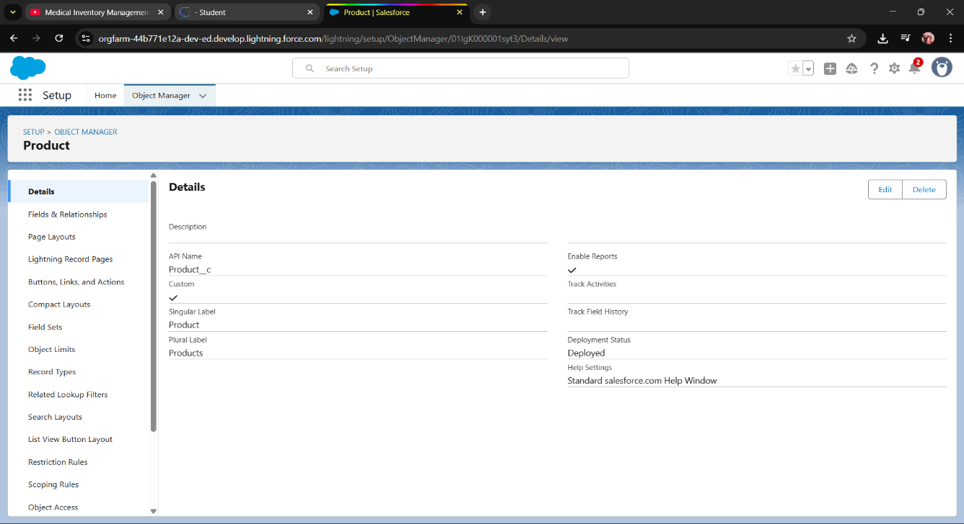

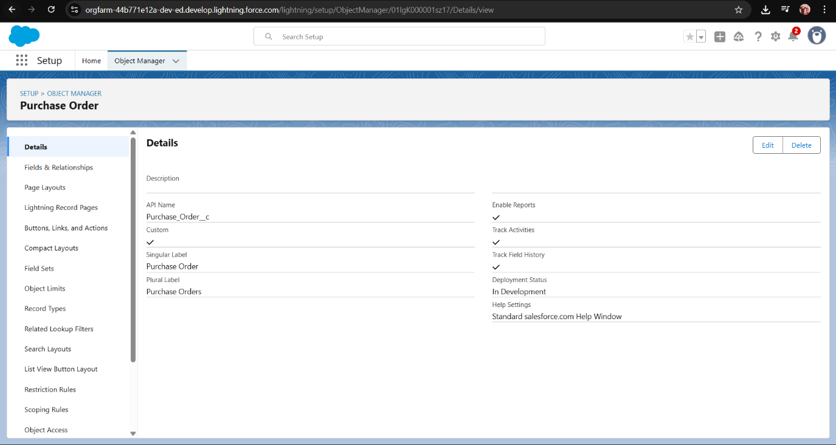

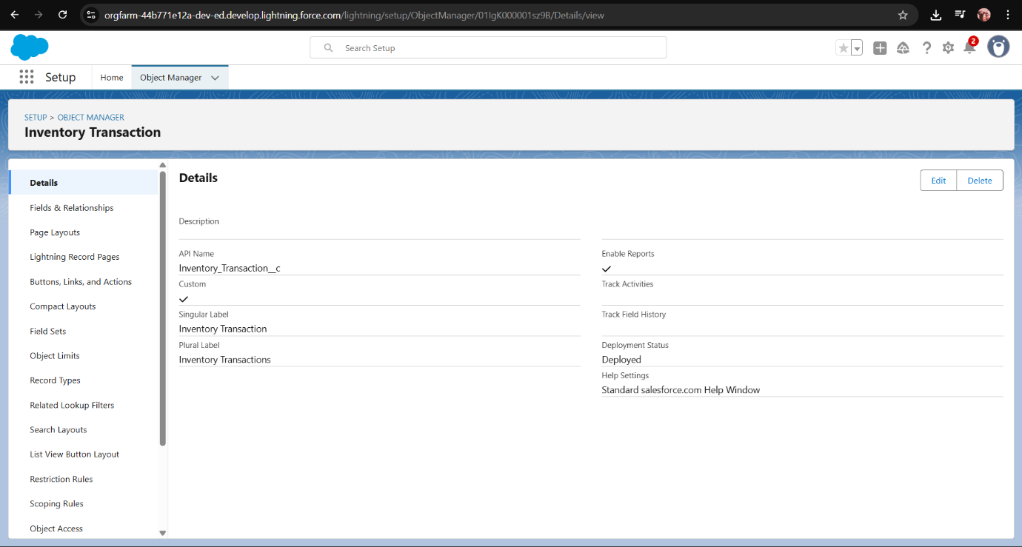

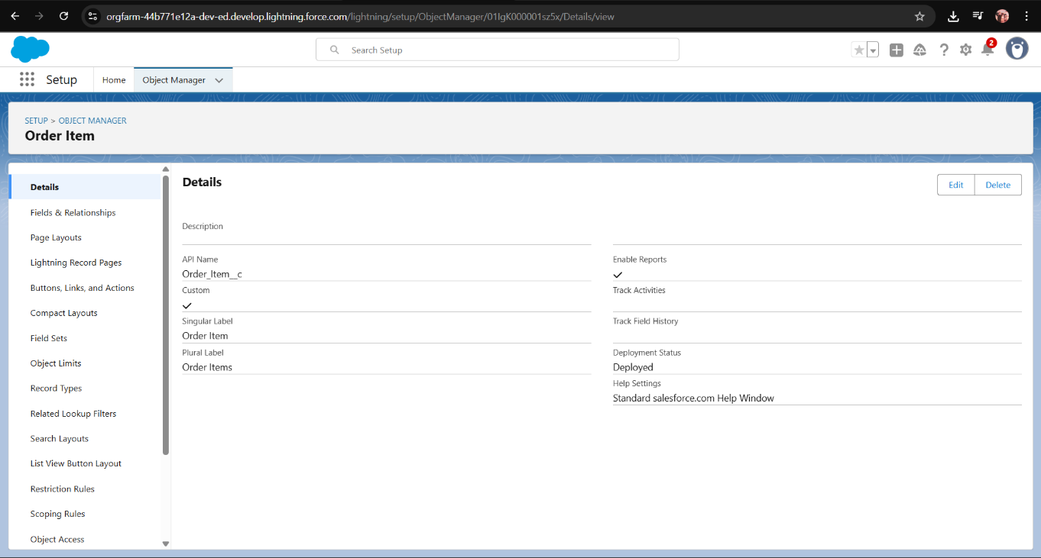

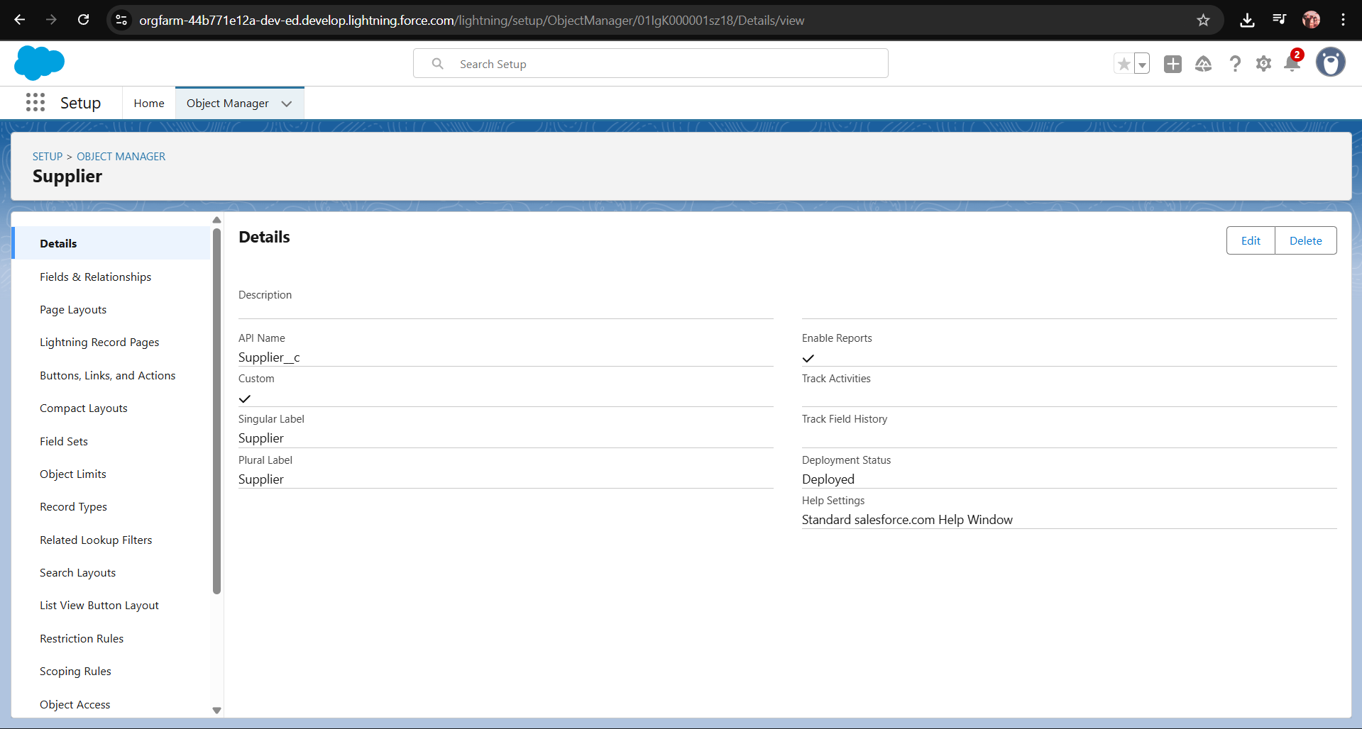

**Creating a tab for Product Object**

**The Lightning App**

**Configured fields and relationship :**

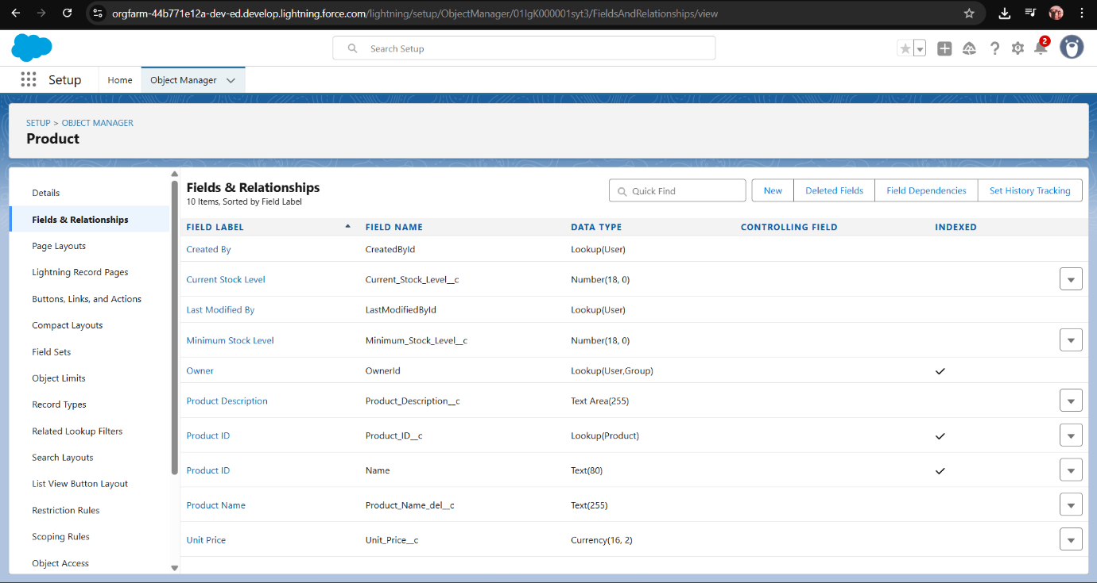

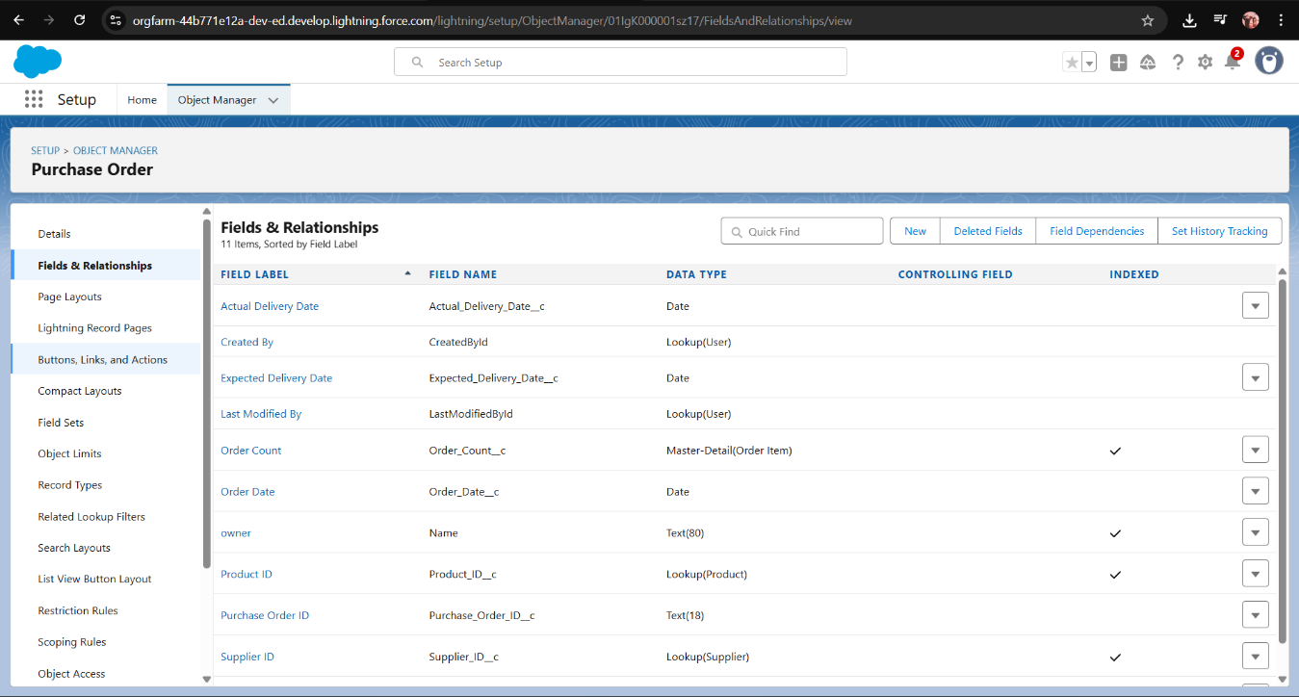

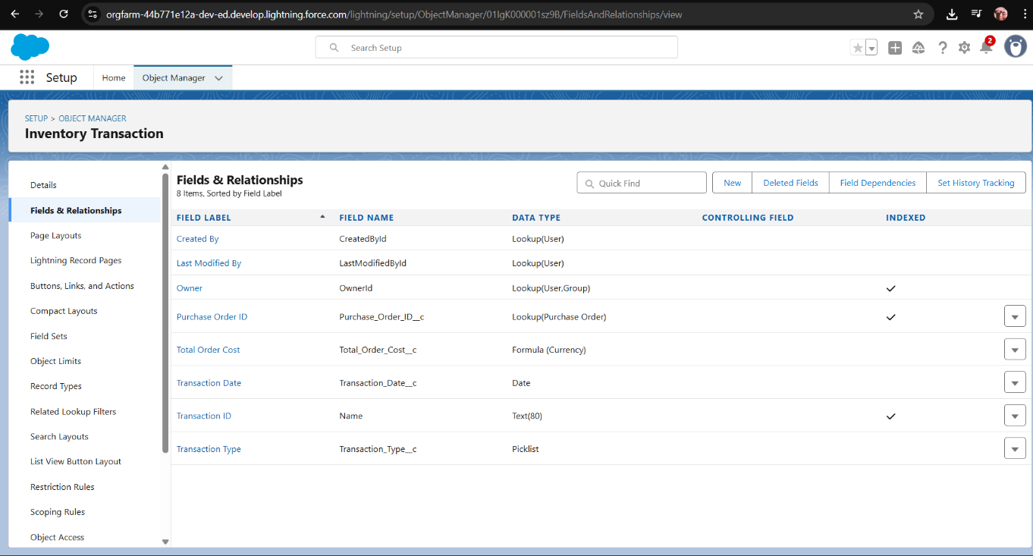

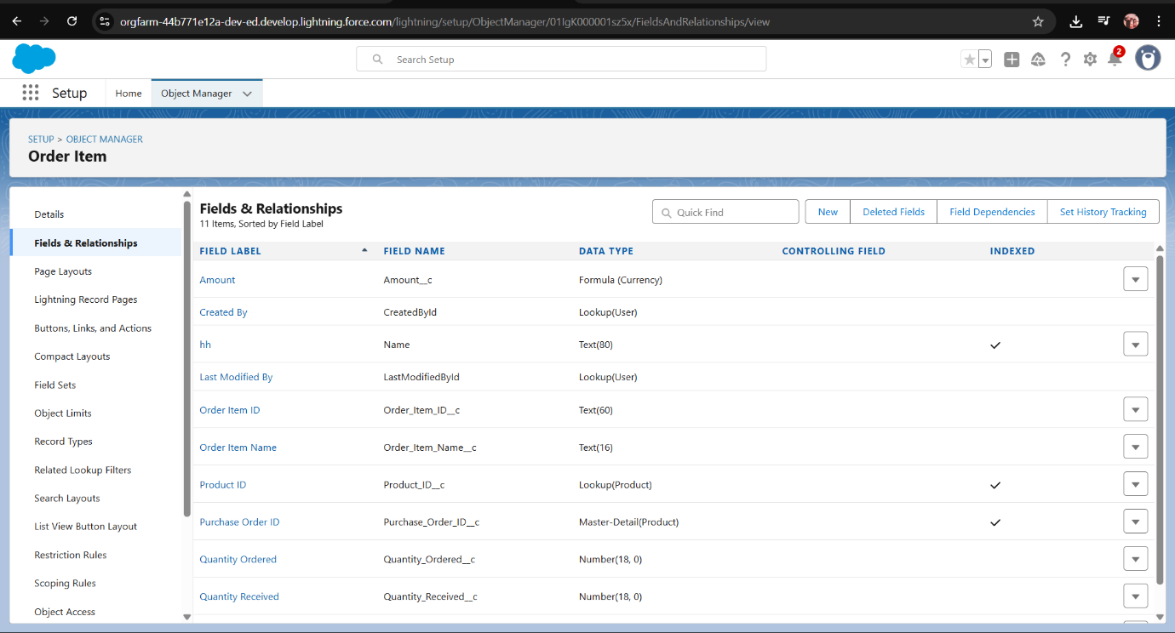

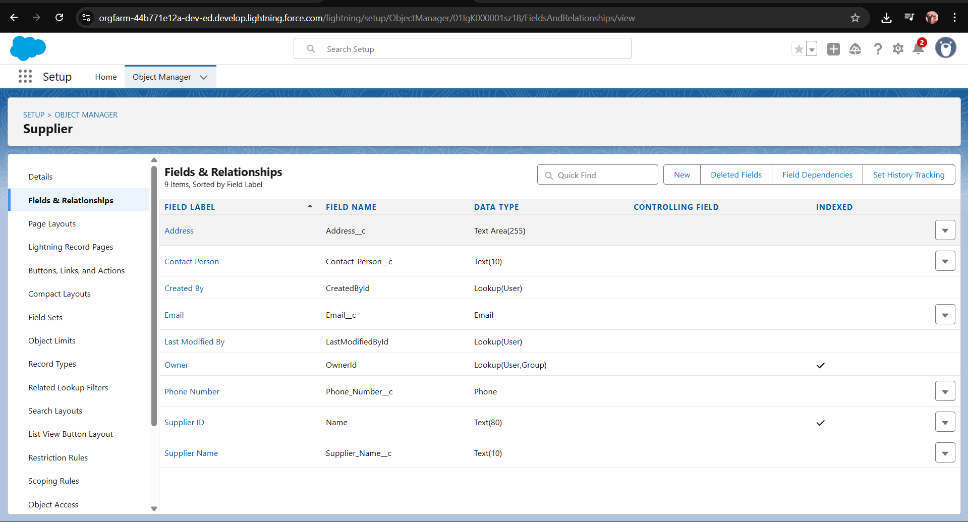

**Editing of Page Layouts**

**Compact Layouts**

**Validation Rules**

**Profiles**

**Roles**

**Permission Sets**

**Create Flow to update the Actual Delivery Date**

**Triggers**

**Reports**

**Dashboards**

